Question 1
Z=0
S=0F
C=0
- Jg greater will not be taken
- Jl smaller will be taken
- Ja above will be taken
- Jb below will not be taken
Question 2
[ORG 0x0100]
;searching 23 in the binary tree

;counting the total no of elements in the sorted array
mov DI,0
mov al,[Array+DI]
again:
inc DI
mov al,[Array+DI]
cmp al,0
jne again
mov dx,DI
;dx stores the total no of elements in the array
mov ax,DI
mov bl,2
div bl
mov cx,ax
;cx now stores the middle index of the array
;checking the midle index
mov DI,ax
mov al,[Array+DI]
mov bl,23
cmp al,bl
je equal
cmp al,bl
jg upper_class
;lower_class
mov ax,cx
mov bx,2
div bx
mov DI,ax
mov al,[Array+DI]
mov bl,23
cmp al,bl
je equal
cmp al,bl
jg upper
;lower
mov ax,DI
mov bx,2
div bx
mov DI,ax
mov al,[Array+DI]
mov bl,23
cmp al,bl
je equal
cmp al,bl
jg up
dec DI
mov ax,DI
mov bx,2
div bx
mov DI,ax
mov al,[Array+DI]
mov bl,23
cmp al,bl
je equal
mov ax,0
jmp end

up:
inc DI
mov ax,DI
mov bx,2
div bx
mov DI,ax
mov al,[Array+DI]
mov bl,23
cmp al,bl
je equal
mov ax,0
jmp end

upper_class:
sub dx,cx
mov ax,dx
mov bx,2
div bx
add ax,cx
;checking upper_class' middle index
mov DI,ax
mov al,[Array+DI]
mov bl,23
cmp al,bl
je equal
cmp al,bl
jg greater
;lesser
mov ax,DI
mov bx,cx
sub ax,bx
add ax,cx
mov DI,ax
mov al,[Array+DI]
mov bl,23
cmp al,bl
je equal
cmp al,bl
jg up
dec DI
mov ax,DI
mov bx,2
div bx
mov DI,ax
mov al,[Array+DI]
mov bl,23
cmp al,bl
je equal
mov ax,0
jmp end

greater:
mov ax,dx
mov bx,DI
sub ax,bx
add ax,DI
mov DI,ax
mov al,[Array+DI]
mov bl,23
cmp al,bl
je equal
cmp al,bl
jg up
dec DI
mov ax,DI
mov bx,2
div bx
mov DI,ax
mov al,[Array+DI]
mov bl,23
cmp al,bl
je equal
mov ax,0
jmp end

upper:
mov ax,cx
mov bx,DI
sub ax,bx
add ax,cx
mov DI,ax
mov al,[Array+DI]
mov bl,23
cmp al,bl
je equal
cmp al,bl
jg up
dec DI
mov ax,DI
mov bx,2
div bx
mov DI,ax
mov al,[Array+DI]
mov bl,23
cmp al,bl
je equal
mov ax,0
jmp end

equal:
mov ax,1

end:
MOV AX, 0x4C00 ; TERMINATE PROGRAM
INT 0x21

Array: db 2,5,8,12,16,23,38,56,72,91,0
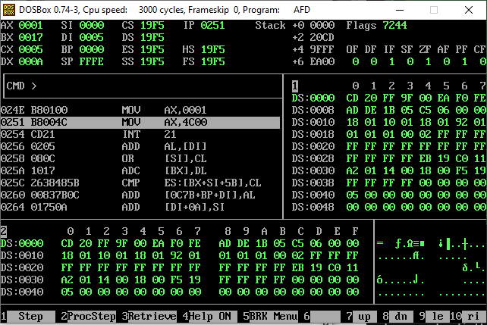
Question 3
[ORG 0x0100]
;dx contains the factorial found of the number
mov dx,0
mov cx,1
;bl contains the no. for factorial
mov bl,5
mov al,bl
cmp al,dl
je zero_ka_factorial_one_hota_hai
dec bl
again:
MUL bl
dec bl
cmp bl,cl
jg again
mov dx,ax
jmp end
zero_ka_factorial_one_hota_hai:
mov al,1
mov dx,ax
end:
MOV AX, 0x4C00 ; TERMINATE PROGRAM
INT 0x21
